Welcome!
Date
Name
Spouse
Address
City
State Zip _________
Email

Please Contact By
❑ Card  Phone  Visit

Telephone Best Time to Call
Home ______________
Work ______________

Guest: First Time Second Time
Are you a church member: yes no
Church
City, State

Circle Appropriate Age/Grade Group(s)
Preschool: Ages: B-1 2-3 4-5
Children: Grades: K 1 2 3 4 5 6
Youth: Grades: 7 8 9 10 11 12
Adults: Ages:18-29 30s 40s 50s 60s+

How did you learn about our church?
Newspaper Friend Yellow Pages Mail
Other

I am a guest of:

New in the Community? Yes No
Names & ages of children at home

Weekly Service & Activity Schedule

Nov 19, 2017
9:45 a.m. Sunday School
11:00 a.m. Worship Service
No Evening Service

Week of Nov 19, 2017
Wednesday 6:30 pm……………..……….Meal/Bible Study
Friday 6:30 pm……………..……………..Men’s 42 Night

November
23……………………………….…………..Thanksgiving
December
3………………………..……New Commandment Kids
3…....Sr Women & Men’s SS Class Christmas Lunch
3…...New Commandment Kids/Elgin Nursing Home
3-10……….Week of Prayer for Lottie Moon Missions
10……………………………New Commandment Kids
10………………Christmas Program/Evening Service
14…………………………….………..Adult Fellowship
14…………………..…….Adult I Sunday School Class Party
Thanksgiving Boxes
Today is the last day to bring items. The boxes will be packed and delivered Monday. Anyone wishing to help can meet in the Fellowship Hall at 6:30 pm.

NEW COMMANDMENT KIDS
December 3
Practice for the Christmas Program will be during Sunday School time.
Also, they will be traveling to the Elgin Nursing Home at 2:00 pm to hand out Christmas cards and the puppets will sing songs. All are welcome to come along to help and sing.

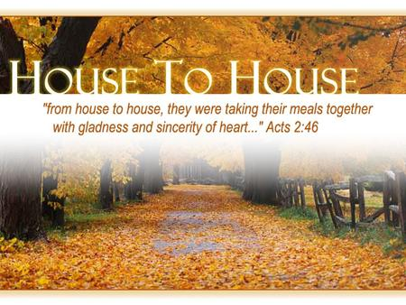
WELCOME

Knobbs Springs Baptist Church

Nov 19, 2017

Church Information:

KnobbsSpringsBC.com KnobbsSpringsBaptist@gmail.com

1662 CR 305, McDade, Texas 78650 512-273-2743

David Atwood, Pastor Cell 512-470-5098

Patti Radford, Office Manager Cell 512-968-7821

